A COMMUNITY SERVICE PROJECT REPORT

ON

WASTE MANAGEMENT

## Submitted in partial fulfillment for the award of the degree of

BACHELOR OF TECHNOLOGY

in

Computer Science and Engineering

By

PRATTI GAYATRI

22A81A05I2

Under the Esteemed Supervision of

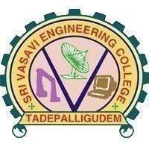MRS. D.S.L MANIKANTESWARI Assistant Professor

Department of computer science and Engineering (Accredited by N.B.A)

## SRI VASAVI ENGINEERING COLLEGE(Autonomous)

(Affiliated to JNTUK, Kakinada)Pedatadepalli, Tadepalligudem-534101, AP 2022-23

SRI VASAVI ENGINEERING COLLEGE

(Autonomous)

Department of Computer Science and Engineering

Pedatadepalli, Tadepalligudem

This is to certify that the Community Service

Project Report entitled “WASTE MANAGEMENT” survey done in Amalapuram village, submitted by Pratti Gayatri( 22A81A05I2 ) , for the award of the degree of Bachelor of Technology in the Department of Computer Science and Engineering during the academic year 2022-2023.

|  |  |
| --- | --- |
| Name of Project Guide | Head of the Department |
| Mrs.D.S.L Manikanteswari | Dr.D.Jaya Kumari |

Assistant professor Professor & HOD

ACKNOWLEDGEMENT

First and foremost, we sincerely salute to our esteemed institute SRI VASAVI ENGINEERING COLLEGE, for giving us this golden opportunity to fulfill our warm dream to become an engineer. Our sincere gratitude to our project guide Mrs.D.S.L Manikanteswari Assistant Professor, Department of Computer Science and Engineering, for her timely cooperation and valuable suggestions while carrying out this project.

We express our sincere thanks and heart full gratitude to Dr. D. Jaya Kumari, M.Tech, Ph.d, Professor & Head of the Department of Computer Science and Engineering, for permitting us to do our project. We express our sincere thanks and heart full gratitude to Dr. G.V.N.S.R. Ratnakara Rao, Principal, for providing a favorable environment and supporting us during the development of this project.

Our special thanks to the management and all the teaching and nonteaching staff members, Department of Computer Science and Engineering, for their support and cooperation in various ways during our project work. It is our pleasure to acknowledge the help of all those respected individuals.

We would like to express our gratitude to our parents, friends who helped to complete this project.

P.Gayatri

(22A81A05I2)

## SRI VASAVI ENGINEERING COLLEGE

(Autonomous)

Department of Computer Science and Engineering

Pedatadepalli, Tadepalligudem

(2022-2023)

Community Service Project for the UG Program

WASTE MANAGEMENT

Name of the Student Regd No

Branch

Semester Topic

: Pratti Gayatri

: 22A81A05I2

: CSE

: II

: WASTE MANAGEMENT

Area : Jeelugumilli

Project Guide

: Mrs.D.S.LManikanteswari Asst.Professor

(Project Guide)

(Student) Mrs.D.S.LManikanteswari

Asst.Professor

# CONTENTS:

## Introduction

* Awareness on waste management

## Awareness forms on awareness program

* Photographs of Surveys

## Observation

* Suggestions
* conclusion

# INTRODUCTION

Waste management or waste disposal includes the processes and actions required to manage waste from its inception to its final disposal. This includes the collection, transport, treatment and disposal of waste, together with monitoring and regulation of the waste management process and waste-related laws, technologies, economic mechanisms. Waste can be solid, liquid, or, gases and each type has different methods of disposal and management. Waste management deals with all types of waste, including industrial, biological, household, municipal, organic, biomedical, radioactive wastes. In some cases, waste can pose a threat to human health.

Health issues are associated throughout the entire process of waste management. Health issues can also arise indirectly or directly: directly through the handling of solid waste, and indirectly through the consumption of water, soil and food. Waste is produced by human activity, for example, the extraction and processing of raw materials.

Waste management is intended to reduce adverse effects of waste on human health, the environment, planetary resources and aesthetics. The aim of waste management is to reduce the dangerous effects of such waste on the environment and human health. A big part of waste management deals with municipal solid waste, which is created by industrial, commercial, and household activity, Waste management practices are not uniform among countries (developed and developing nations); regions (urban and rural areas), and residential and industrial sectors can all take different approaches.

Proper management of waste is important for building sustainable and liveable cities, but it remains a challenge for many developing countries and cities. A report found that effective waste management is relatively expensive, usually comprising 20%–50% of municipal budgets. Operating this essential municipal service requires integrated systems that are efficient, sustainable, and socially supported. A large portion of waste management practices deal with municipal solid waste (MSW) which is the bulk of the waste that is created by household, industrial, and commercial activity. According to the Intergovernmental Panel on Climate Change (IPCC), municipal solid waste is expected to reach approximately 3.4 Gt by 2050; however, policies and law making can reduce the amount of waste produced in different areas and cities of the world. Measures of waste management include measures for integrated techno-economic mechanisms of a circular economy, effective disposal facilities, export and import control and optimal sustainable design of products that are produced.

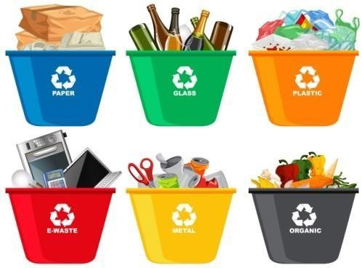 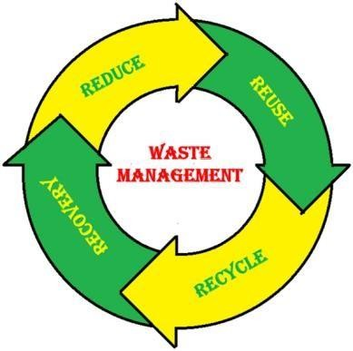

ľypes of Waste Management

the most popular types of Waste Management are:

* Recycling
* Incineration
* Landfill
* Biological Reprocessing
* Animal Feed

# Recycling:

Recycling makes a huge difference in protecting the environment. Amongst the various types of waste management, recycling means that garbage is not disposed of in landfills or waste sources by making usable litter components. Many entities/communities have made it easier to recycle goods by introducing labelling to show whether or not a material is

recyclable.

# Incineration:

this type of waste management includes the disposal of waste materials by means of burning. the thermal treatment is another name for this disposal method. You may incinerate on a commercial or human scale and dispose of a broad variety of waste

material’s. Most countries with limited land consider the incineration process. You may use the power produced by burning waste material’s to produce heat, energy or steam. One of the drawbacks of this disposal process is that it can be a source of air pollution.

# Landfill:

It is one of the most popular types of waste management systems in the world. It includes the collection, [**transportation**,](https://leverageedu.com/blog/transportation-engineering/) disposal and buying of waste in designated property. Many towns are planning deserted and bailed areas to cope with waste.

Authorities are committed to ensuring that the construction of each landfill is successful in terms of sanitation and economic land use. However, landfill sites are a significant cause of health and environmental problems that concern many communities. For instance, gas from these landfills is often incredibly dangeíous.

# Biological Processing:

Chemical waste material’s, such as kitchen waste and paper goods, can be reused after a procedure called biological reprocessing which is another popular system amongst the

varied types of waste management. Multiple physiological systems, including [**recycling**](https://leverageedu.com/blog/waste-management/) and biomass gasification, are used in biological eProcessing. Composing is a normal biological mechanism that is citied out under control conditions. One of the ends of the stock is natural gas, which is used to produce heat and electricity. [**Biological**](https://leverageedu.com/blog/scope-of-biology/) eProcessing is commonly used for the disposal of industrial waste.

# Animal feed:

Food waste is a serious issue and needs serious consideration. According to

the [**United States**](https://leverageedu.com/blog/study-in-usa-success-stories/) Department of Agriculture, between 30 and 40 percent of all food created by the United States is spent on food by retailers and customers. this is a major problem as the food value is estimated to be $161 billion. the nation is leading the world in terms of food waste, and the cause is self-explanatory. Food can be preserved by manure and livestock feed and this is also one of the ecological types of waste management methods.

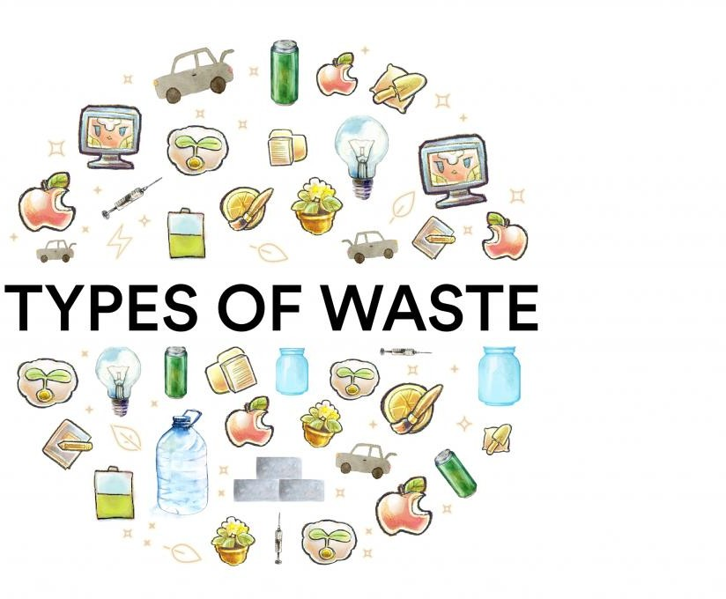

# PHOTOGRAPHS OF SURVEY :

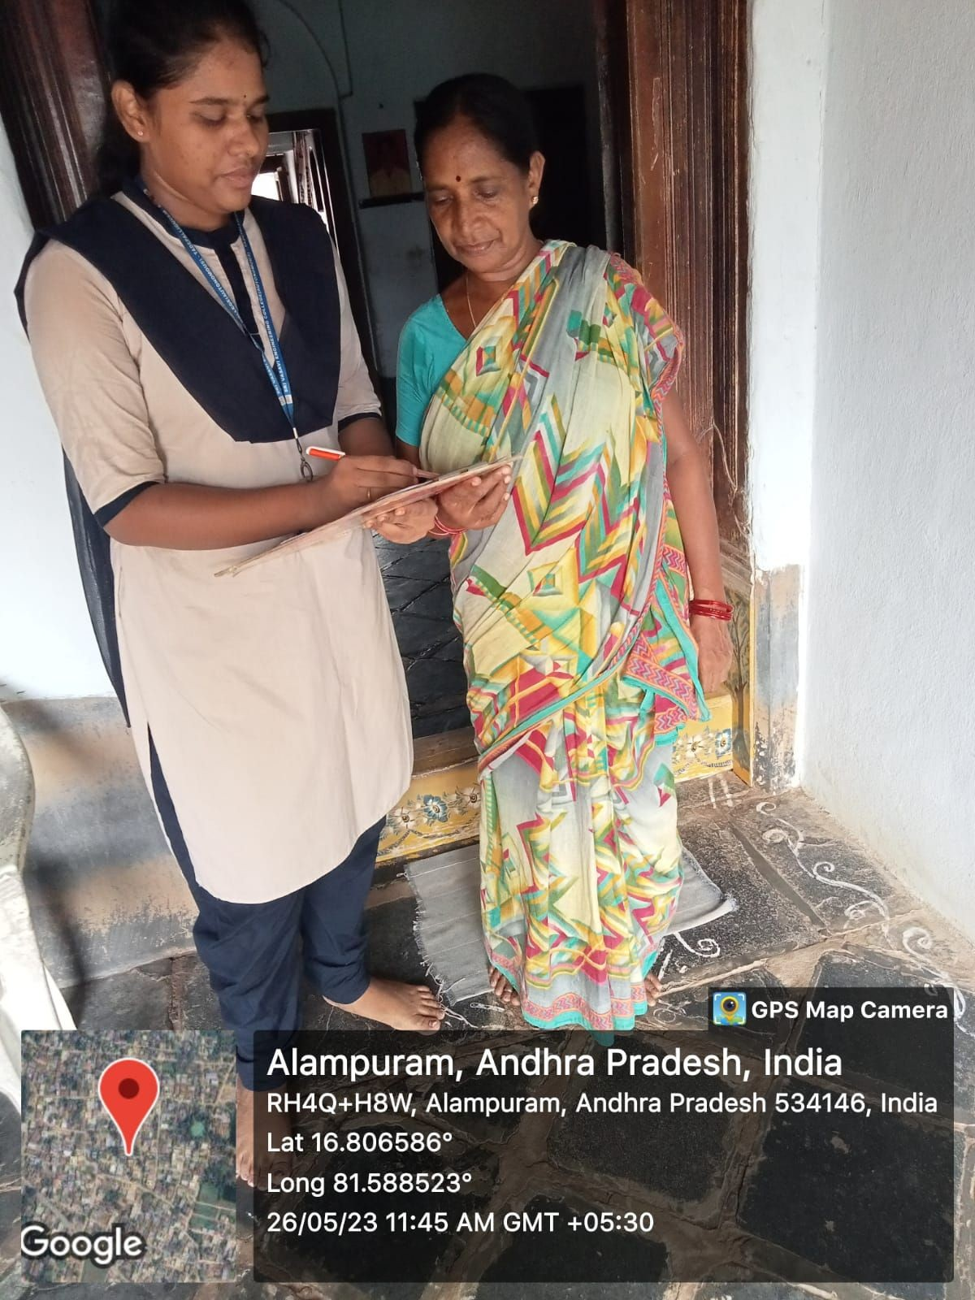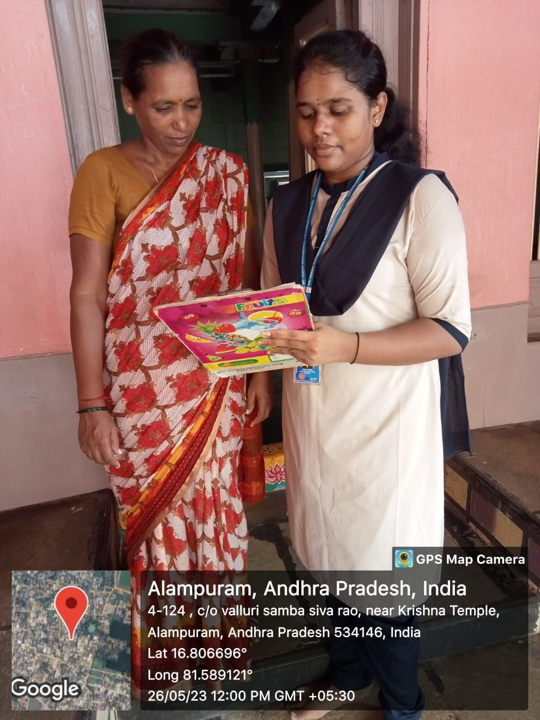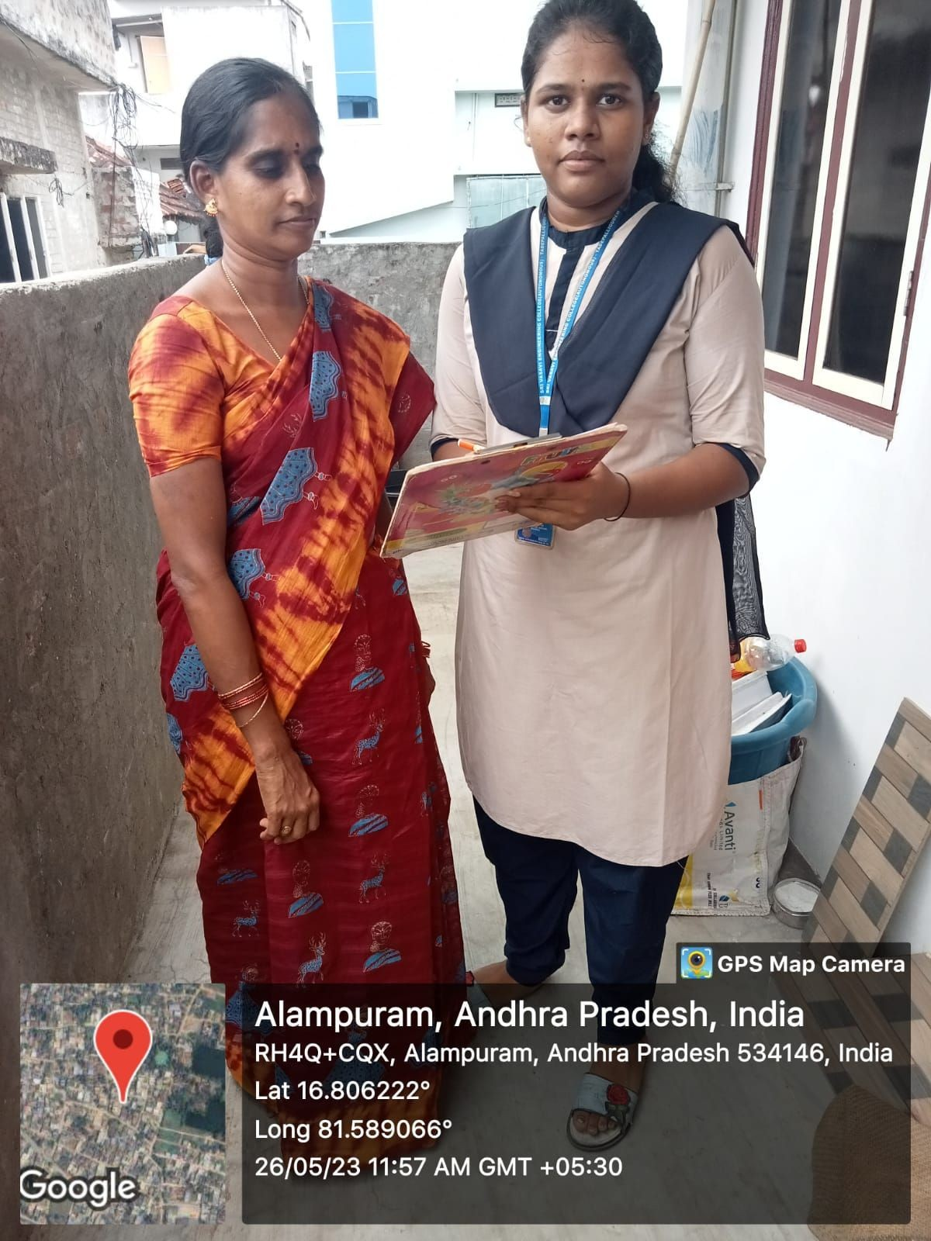

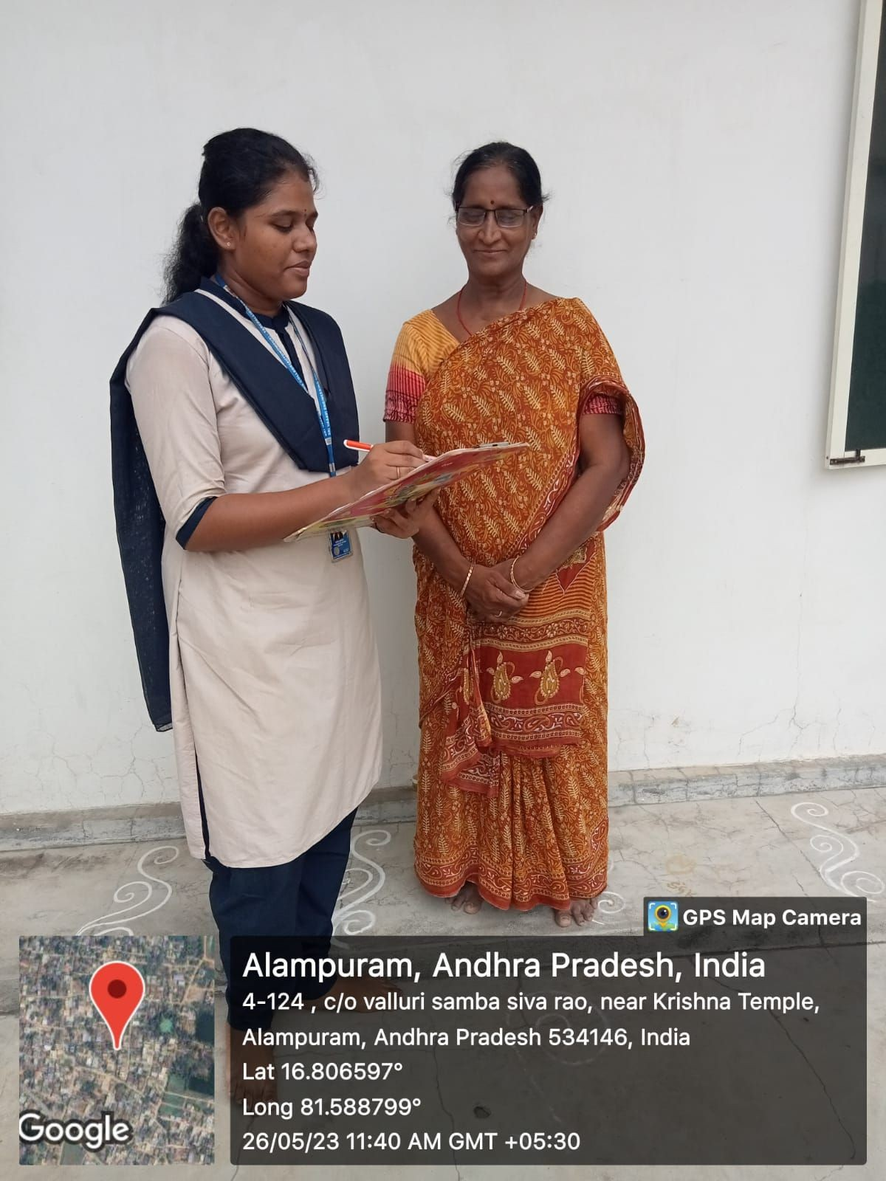

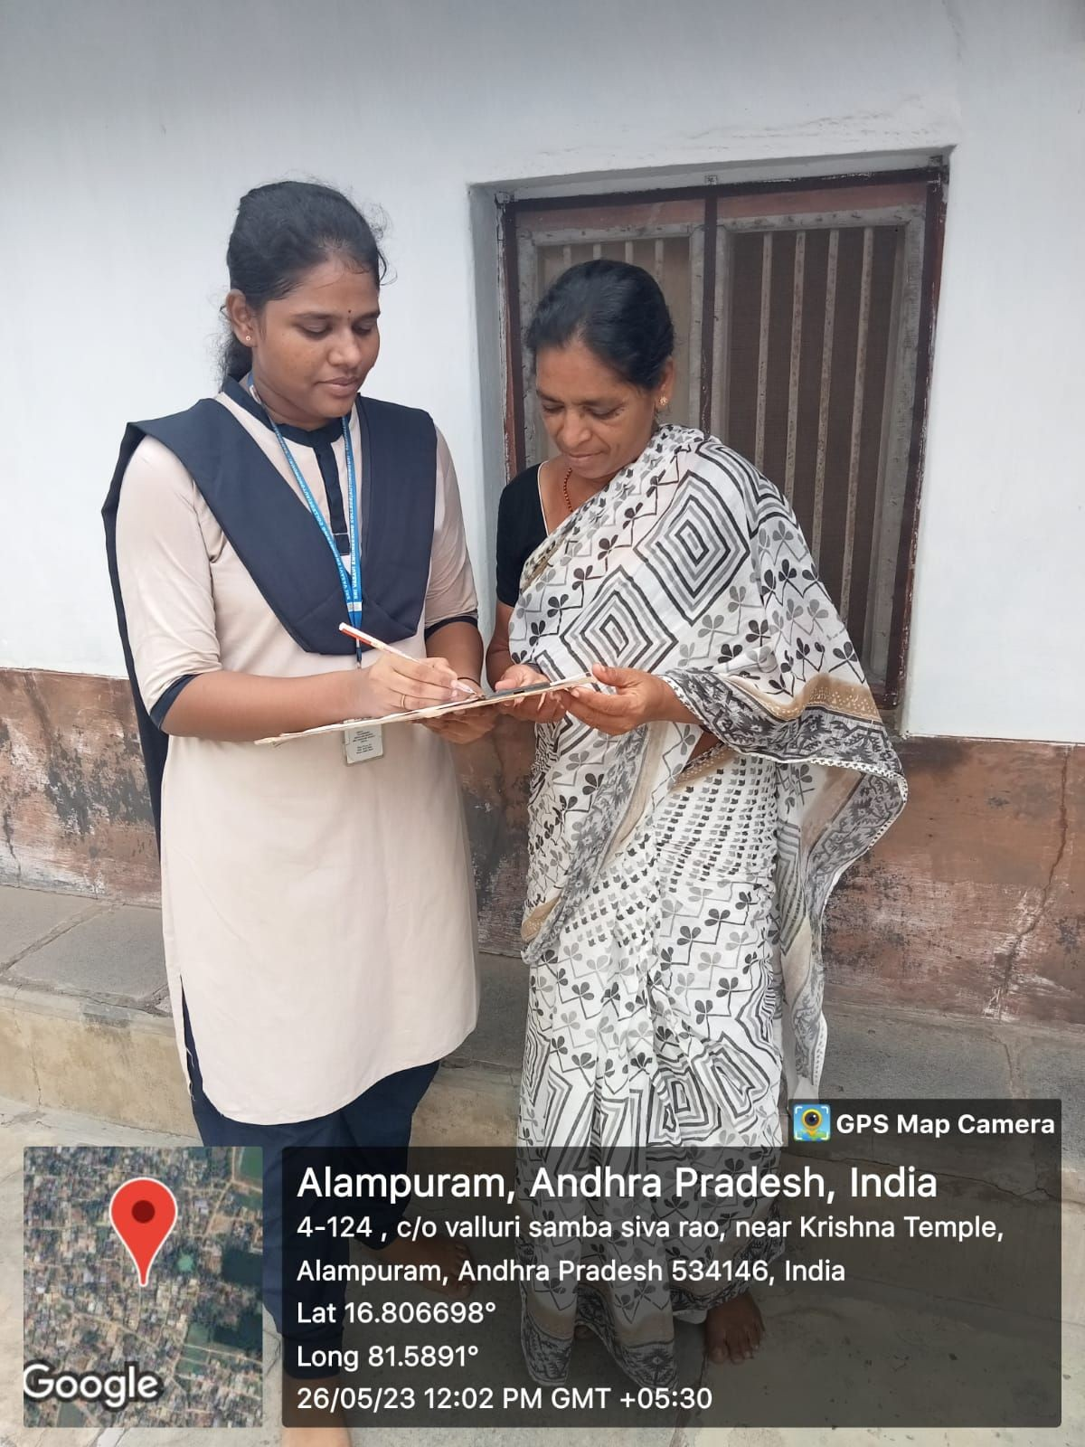 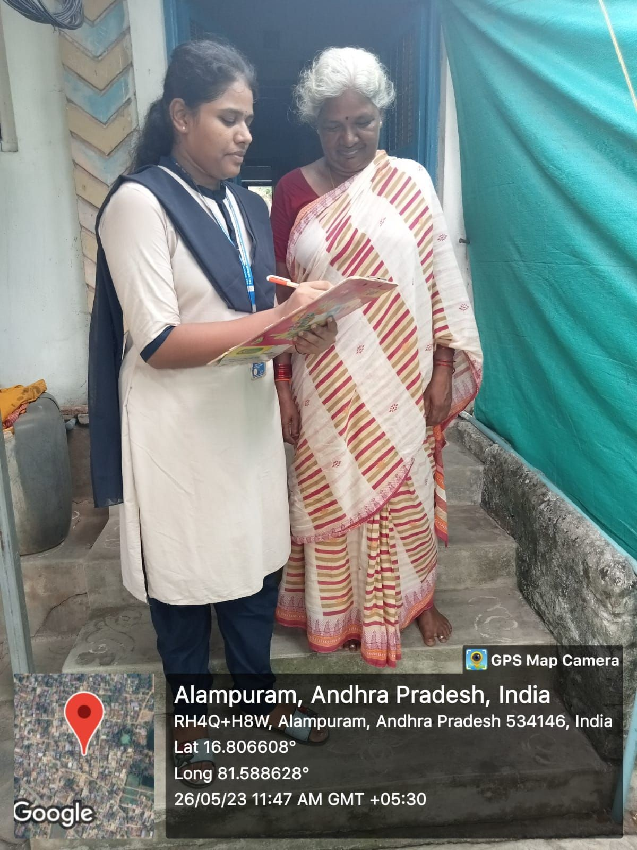

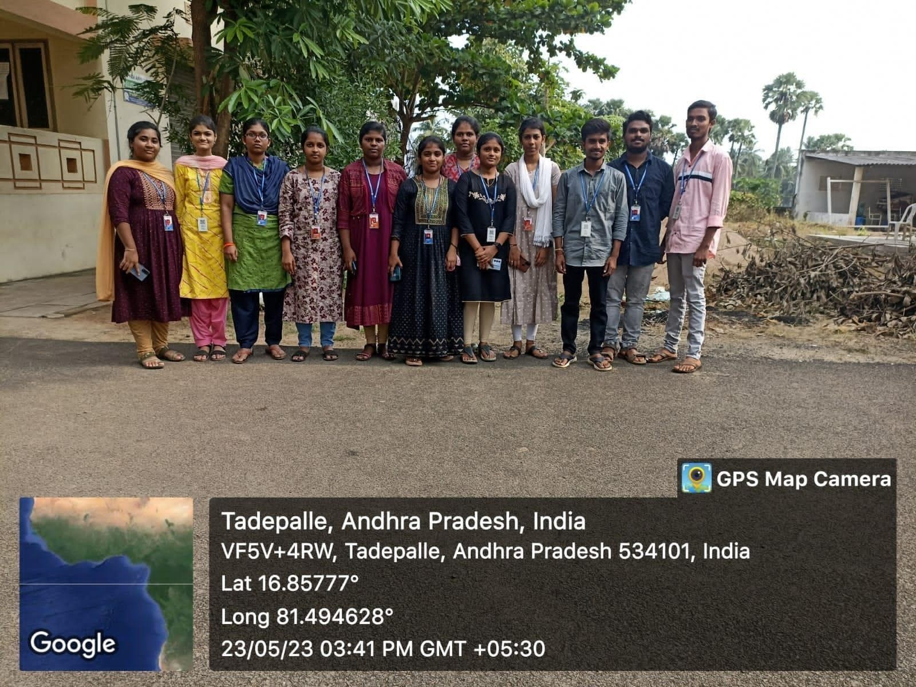

# OBSERVATION :

* Relook at defining the collection streams to include wet/organic which is predominantly kitchen waste, dry waste which includes recyclable and non-commercial (non-recyclable) dry waste and sanitary waste including hazardous waste. It is important to separate the sanitary from dry waste.
* Remove the use of the word combustible waste which is not a good enough differentiator, as all dry waste is combustible but is not desirable. Dry waste should be differentiated as either recyclable or non-recyclable only.
* Recognize the individual waste types as independent waste streams and replace the use of the generic word SOLID WASTE with individual waste types to recognize the differences in their handling and processing. Ensure the data collection and measure of individual waste types and not of the umbrella term SOLID WASTE in all Reporting Formats.
* Strengthen the implementation of the Rules with not just defining of time frames for implementation but also goal setting defining targets to be achieved and penal provisions for failure to implement or reach the required targets.
* Recognize the need for separate collection of household ewaste Re-look at tipping fee and viability gap funding in the context of decentralizing, putting in practice principles of waste hierarchy.
* Redefine with more detail and clarity the Waste collection and Storage defining Bin System standards with standardized Colour coding for waste streams; Norms for storage in Apartments, commercial complexes and Handover of waste.

# SUGGESTIONS

* Use reusable grocery bags, and not just for groceries
* Avoid single use food and drink containers and utensils
* Tracking of waste collection and reduction
* Support your local farmers
* Purchase wisely and recycle
* Follow 3R rule

RECYCLE, REUSE, REDUCE

* Use dust bins in every house-maintain colour code and use different dust bins for different types of waste
* Give the awareness on WASTE MANAGEMENT in our locality
* Preventing and minimising waste disposal
* Ditch disposal in the kitchen
* Try a new to buy clothes
* Avoid open dumping and must utilize the waste disposal points
* Sanitary landfills are the most common method to manage the waste
* Sustainable way to manage waste is to recycle and compost

# CONCLUSION:

The behavior of generating garbage is too dangerous not only for today’s generation, but also for future generations. It is critical to educate people and encourage them to practice RECYCLE, REUSE, and REDUCE instead of producing waste. Waste disposal should be a priority for municipalities and governments.

Waste management is intended to reduce adverse effects of waste on human health, the environment, planetary resources and aesthetics. The aim of waste management is to reduce the dangerous effects of such waste on the environment and human health.

In trash management, the 3R principle is extremely useful. Recycle, reuse, and cut down on waste. Public awareness is important. Waste management is a critical issue that requires immediate government intervention.

Since 1990, India's trash has altered due to two decades of economic expansion. Due to rising population and changing lifestyles, the amount of MSW generated in India is continually increasing. There is a scarcity of land , and public health and environmental resources are valuable. The current SWM dilemma in India should be treated holistically; while long-term remedies should be considered, the current problems must be select one or more addressed first.

It is critical to improve SWM in India. Improper SWM puts public health, India's environment, and Indians' quality of life in jeopardy. India should of these choices, or a combination of them, that will benefit the country.

|  |  |
| --- | --- |
| Student name | Pratti Gayatri |
| Regd.no | 22A81A05I2 |
| Branch | CSE |
| Year | 2022-2023 |
| Title | WASTE MANAGEMENT |
| Guide Name | Mrs.D.S.L MANIKANTESWARI |

|  |  |  |  |  |  |
| --- | --- | --- | --- | --- | --- |
| S.No | DATE | Guidance Given | Student activities | Target Achieved | Signature of Guide |
|  |  |  |  |  |  |
|  |  |  |  |  |  |
|  |  |  |  |  |  |
|  |  |  |  |  |  |
|  |  |  |  |  |  |
|  |  |  |  |  |  |
|  |  |  |  |  |  |
|  |  |  |  |  |  |
|  |  |  |  |  |  |
|  |  |  |  |  |  |

Project Guide Project Coordinator Head of the Department